**Analysis of Customer Support Dynamics: Unveiling Patterns with Power BI**

**Introduction**

ABC Company has assigned us the project titled "Customer Support Navigator: An Analytical Overview of Ticket Dynamics." This project aims to provide a comprehensive analysis of customer support tickets, focusing on ticket statuses, response times, and customer interactions. By meticulously collecting and analyzing data, we explore various aspects of customer support operations, including open, closed, and pending tickets, response times, and customer satisfaction trends. Leveraging the capabilities of Power BI, we transform raw data into meaningful insights, enabling stakeholders to gain a deeper understanding of the factors influencing customer support operations. These insights are crucial for support managers, analysts, and customer service teams to make informed decisions and optimize operations effectively.

**Scenario 1: Ticket Status Analysis**

The analysis includes a bar chart visualizing the count of tickets by status (Open, Closed, and Pending Customer Response). This visualization helps quickly identify the distribution of ticket statuses and measure their impact on overall support efficiency. Understanding the proportion of different ticket statuses can help in strategizing for resource allocation, operational improvements, and enhanced customer satisfaction efforts.

**Scenario 2: Response Time Analysis**

A scatter plot representing response times across different tickets offers insights into the efficiency of the support team. This visualization helps in identifying patterns and outliers in response times, assisting in pinpointing areas that may require operational adjustments to improve efficiency and customer experience.

**Scenario 3: Customer Interaction Trends**

The line chart depicting customer interaction trends over time provides a clear view of support activity and fluctuations. By analyzing this data, support managers can gain a deeper understanding of peak support times, customer engagement levels, and seasonal variations. This can inform future staffing and resource planning strategies, helping the support team to maximize efficiency and maintain high levels of customer satisfaction.

**Technical Architecture:**

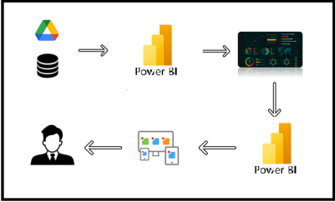

**Project Flow**

To accomplish this, we have to complete all the activities listed below,

* Data Collection
  + Collect the dataset,
  + Connect Data with Power BI
* Data Preparation
  + Prepare the Data for Visualization
* Data Visualizations
  + Visualizations
* Dashboard
  + Responsive and Design of Dashboard
* Report
* Report Creation
* Performance Testing
  + Amount of Data Rendered to DB
  + Utilization of Data Filters
  + No. of Calculation fields
  + No. of Visualizations/Graphs
* Project Demonstration & Documentation
  + Record explanation Video for project end to end solution
  + Project Documentation-Step by step project development procedure

**Milestone 1: Data Collection & Extraction from Database**

Data collection is the process of gathering and measuring information on variables of interest, in an established systematic fashion that enables one to answer stated research questions, test hypotheses, evaluate outcomes and generate insights from the data.

**Activity 1: Downloading the dataset**

Please use the link to download the dataset: [Link](https://www.kaggle.com/datasets/suraj520/customer-support-ticket-dataset)

**Activity 1.1: Understand the data**

Data contains all the meta information regarding the columns described in the CSV files

**Column Description of the Dataset:**

**1.Ticket ID**: Unique identifier for each ticket.

**2.Customer Name**: Name of the customer.

**3.Customer Email**: Email of the customer.

**4.Customer Age**: Age of the customer.

**5.Customer Gender**: Gender of the customer.

**6.Product Purchased**: Product associated with the ticket.

**7.Date of Purchase**: Purchase date of the product.

**8.Ticket Type**: Type of issue reported.

**9.Ticket Subject**: Subject of the ticket.

**10.Ticket Description**: Description of the issue.

**11.Ticket Status**: Current status of the ticket.

**12.Resolution**: Resolution provided for the ticket.

**13.Ticket Priority**: Priority level of the ticket.

**14.Ticket Channel**: Channel through which the ticket was raised.

**15.First Response Time**: Time taken for the first response.

**16.Time to Resolution**: Total time taken to resolve the ticket.

**17.Customer Satisfaction Rating**: Satisfaction rating provided by the customer.

**Milestone 2: Data Preparation**

**Activity 1: Prepare the Data for Visualization**

Preparing the data for visualization involves cleaning the data to remove irrelevant or missing data, transforming the data into a format that can be easily visualized, exploring the data to identify patterns and trends, filtering the data to focus on specific subsets of data, preparing the data for visualization software, and ensuring the data is accurate and complete. This process helps to make the data easily understandable and ready for creating visualizations to gain insights into the performance and efficiency. Since the data is already cleaned, we can move to visualization.

3.1: Data Loading

<https://drive.google.com/file/d/1iEyqvpQyyNK95jdxtjmtJT4H1wXSrWUo/view?usp=sharing>

ra

3.2 Data Cleaning

<https://drive.google.com/file/d/1bVsPLlHjjLCtVYltgoqcGi-8_U29ZVMy/view?usp=sharing>

**Milestone 3: Data Visualization**

Data visualization is the process of creating graphical representations of data to help people understand and explore the information. The goal of data visualization is to make complex data sets more accessible, intuitive, and easier to interpret. By using visual elements such as charts, graphs, and maps, data visualizations can help people quickly identify patterns, trends, and outliers in the data.

**Activity 1: Visualizations**

**Activity 1.1: Avg Customer Satisfaction Rating:**

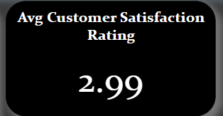

**Insight:** The average customer satisfaction rating is relatively low at 2.99 out of 5.

**Activity 1.2: Most Tickets Raised by**



**Insight:** Michael Garcia has the most tickets at 5.

**Activity 1.3: Most Tickets were raised by Age Group**

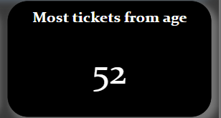

**Insight:** The age group with the most tickets is 52 years old.

**Activity 1.4: Count of stops for each Airlines**

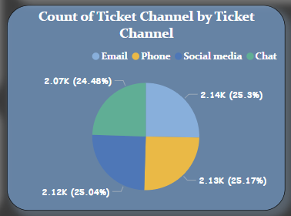

**Insight:** Customer support channels are fairly evenly distributed, with email being slightly more common.

**Activity 1.5: Satisfaction Rating by Ticket Type**

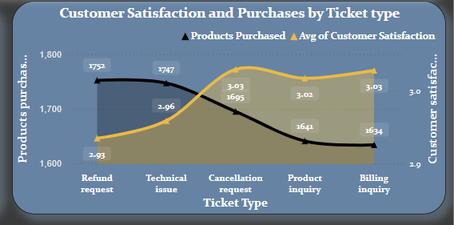

**Insight:** Cancellation request" tickets have the highest customer satisfaction but lowest number of products purchased.

**Activity 1.6 : Ticket Analysis**

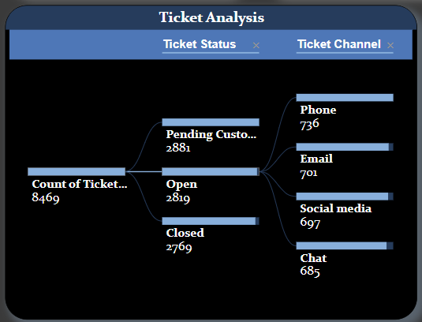

**Insight:** Ticket analysis dashboard showing status, channel distribution for 8,469 total tickets.

**Activity 1.7: Ticket Type and it’s priority**

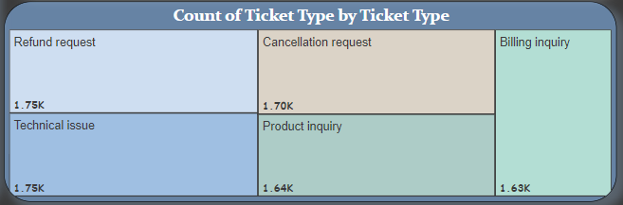

**Insight:** Breakdown of ticket types, including refund requests, cancellation requests, billing inquiries, technical issues, and product inquiries.

**Activity 1.8: Count of Tickets by Ticket Type( Closed, Open, Pending Customer Response)**

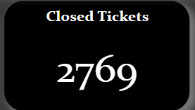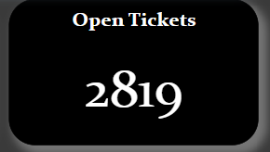

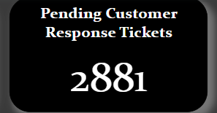

**Insights:** Display of 2,769 closed tickets.

Count of 2,881 pending customer response tickets.

Number of open tickets at 2,819.

**Activity 1.9: Total Products Purchased**

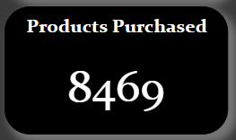

**Insights:** The count of total products purchased are 8469

**Activity 2.1: Slicers**

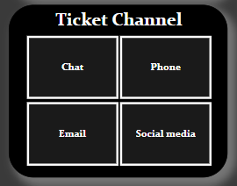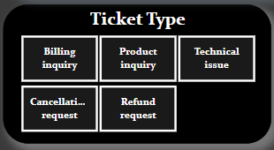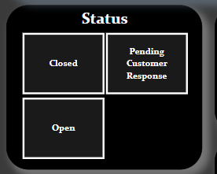

**Insights:** The four images show different categorization schemes for customer support tickets, including ticket types, statuses, and communication channels, presented in a dark-themed, structured layout with white text in rectangular boxes.

**Milestone 4: Dashboard**

A dashboard is a graphical user interface (GUI) that displays information and data in an organized, easy-to-read format. Dashboards are often used to provide real-time monitoring and analysis of data and are typically designed for a specific purpose or use case. Dashboards can be used in a variety of settings, such as business, finance, manufacturing, healthcare, and many other industries. They can be used to track key performance indicators (KPIs), monitor performance metrics, and display data in the form of charts, graphs, and tables.

**Activity 1- Responsive and Design of Dashboard**

**Explanation video link:**

<https://drive.google.com/file/d/1jD4nz1nMSO7kWUfAKqAJDBtruQf4_HDG/view?usp=sharing>

**Dashboard:**

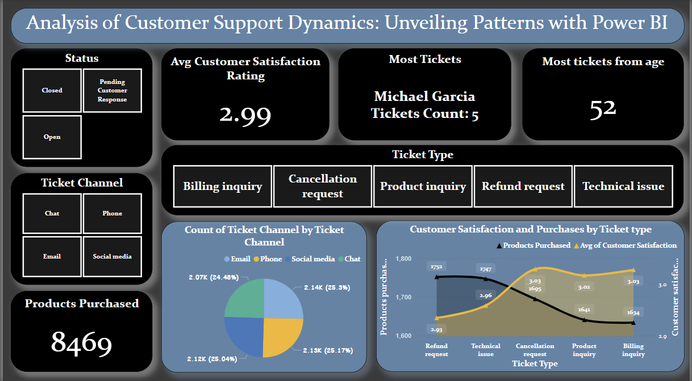

**Milestone 5: Report**

A report is a comprehensive document that provides a detailed and structured account of data analysis, findings, and insights. It is typically used for in-depth analysis, documentation, and communication of results. Reports are suitable for a diverse audience, including decision-makers, analysts, and stakeholders who need a comprehensive understanding of the data.

**Activity 1: Design of Report**

Designing a report in Power BI involves connecting to data sources, creating visualizations like charts and graphs, customizing their appearance and interactivity, organizing them logically on the canvas, formatting elements for consistency and clarity, and optionally creating dashboards for a summarized view. Throughout the process, it's essential to consider the audience's needs and ensure the report effectively communicates insights from the data. Finally, iterate based on feedback to continually improve the report's design and usefulness.

**Explanation video link:**

<https://drive.google.com/file/d/1mX_MCHuNCUacKeybazdojUQacpB_Xt4E/view?usp=sharing>

**Report:**

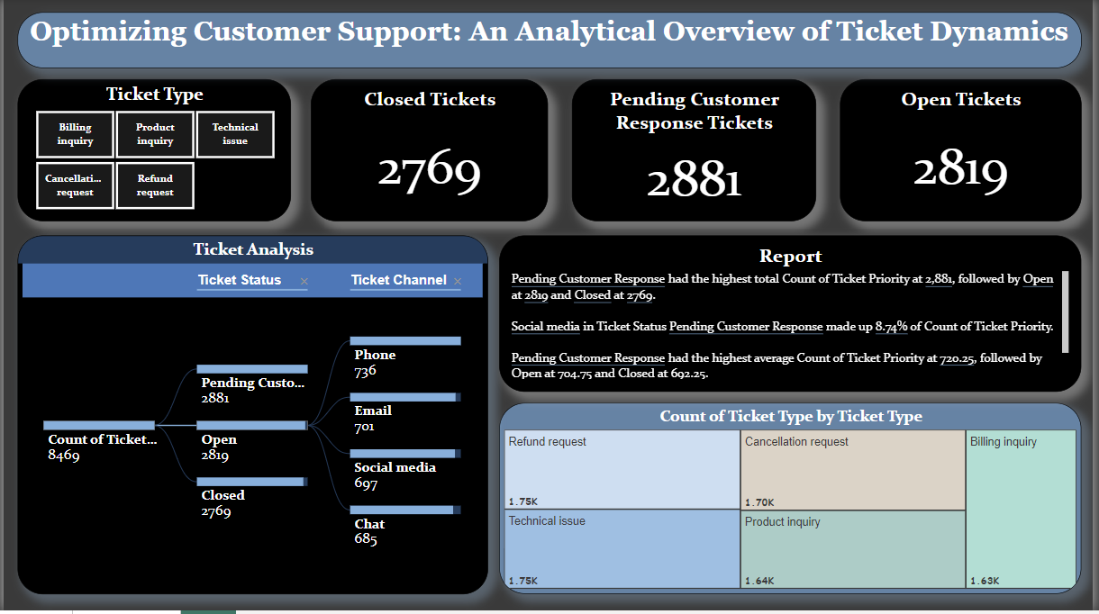

**Milestone 6: Performance Testing**

**Activity 6.1: Amount of Data Rendered to DB**

During the performance testing phase, we focused on evaluating the efficiency and scalability of our database in handling the volume of data generated from college students' food choices and preferences."Amount of Data Loaded" refers to the quantity or volume of data that has been imported, retrieved, or loaded into a system, software application, database, or any other data storage or processing environment. It's a measure of how much data has been successfully processed and made available for analysis, manipulation, or use within the system.

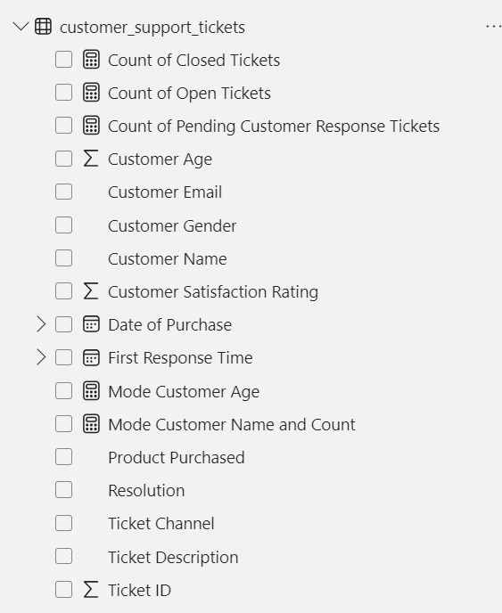

**Activity 6.2:Utilization of Data Filters**

"Utilization of Filters" refers to the application or use of filters within a system, software application, or data processing pipeline to selectively extract, manipulate, or analyze data based on specified criteria or conditions. To enhance the usability and interactivity of the visualizations, several data filters were implemented. These filters allowed users to dynamically explore and analyze the data based on specific criteria. Filters are used to narrow down the scope of data, focusing only on the relevant information that meets certain predefined criteria.

In PowerBI , Filtering is done in 2 ways

1. By Using Filter Pane
2. By Using Slicers

1. **Ticket Type Filter**: Select specific Ticket Types to analyze Customer data.

2. **Status Filter**: Filter visualizations by specific Ticket Status.

3. **Ticket Type Filter:** View data based on ticket type categories.

4. **Ticket Channel Filter**: Filter data by the communication mode of tickets..

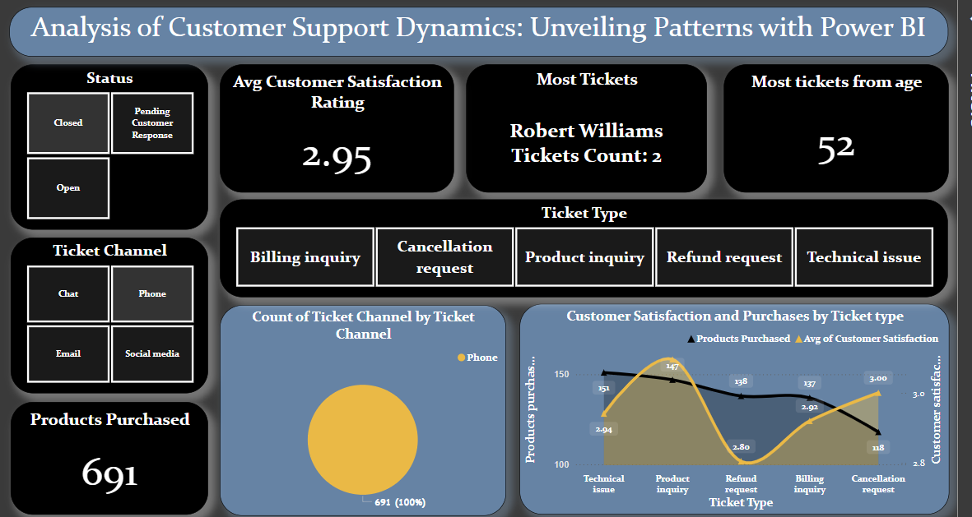

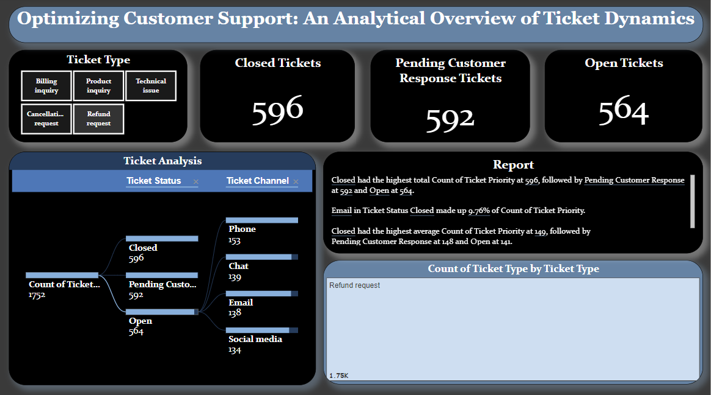

**Milestone 7: Project Demonstration & Documentation**

Below mentioned deliverables to be submitted along with other deliverables

**Activity 1: - Record explanation Video for the project's end-to-end solution**

**Activity 2: - Project Documentation-Step by step project development procedure**

Create document as per the template provided